LAB ASSIGNMENTS 1: Jenkin

What is Jenkins?
Jenkins is an open-source automation server that
helps with the software development process by automating tasks like building,
testing, and deploying.
It's a popular tool for continuous integration (CI) and continuous delivery (CD)

Assignment 1:

First create spring mvc project with spring boot and deploy it on local tomcat server
now we need to do atomize it using Jenkin

- Spring MVC with local tomcat server(Without Jenkins)

Created empapp.war

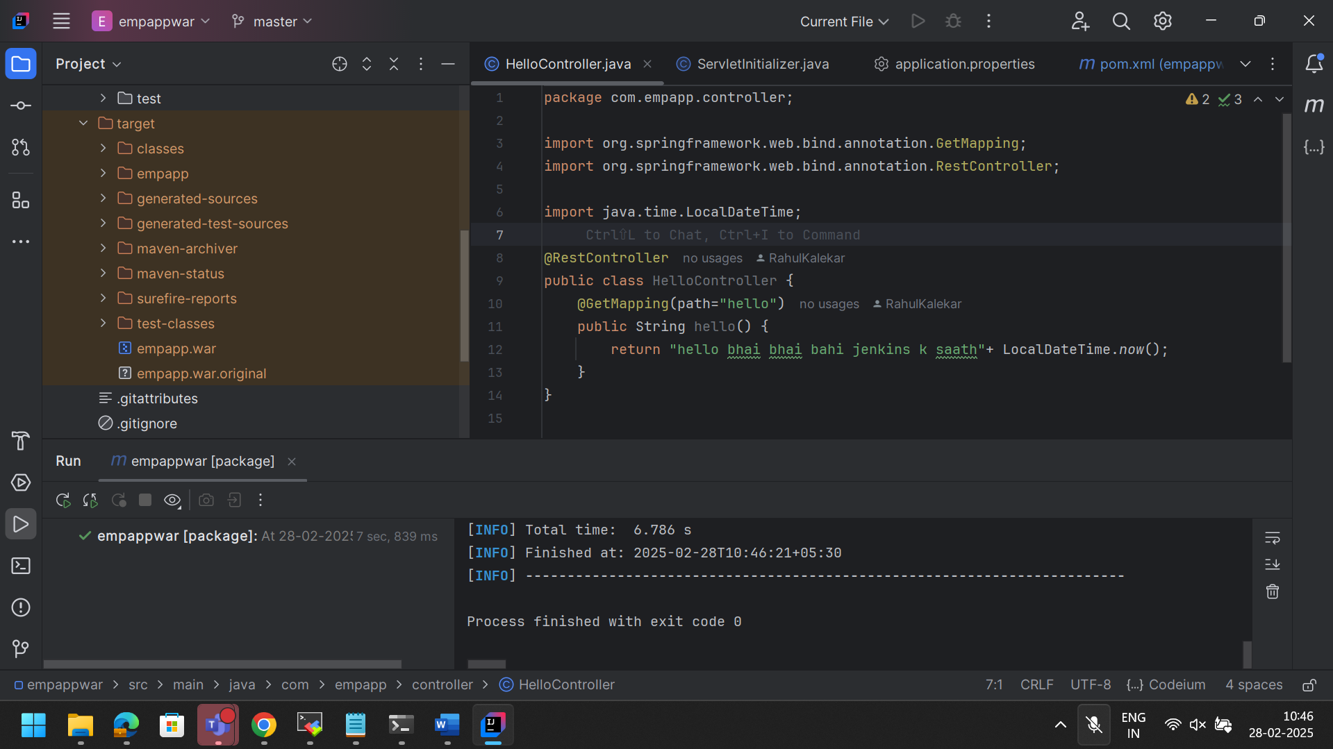

C:\tools\apache-tomcat-9.0.98\conf
In above location , added roles to access tomcat server manager app

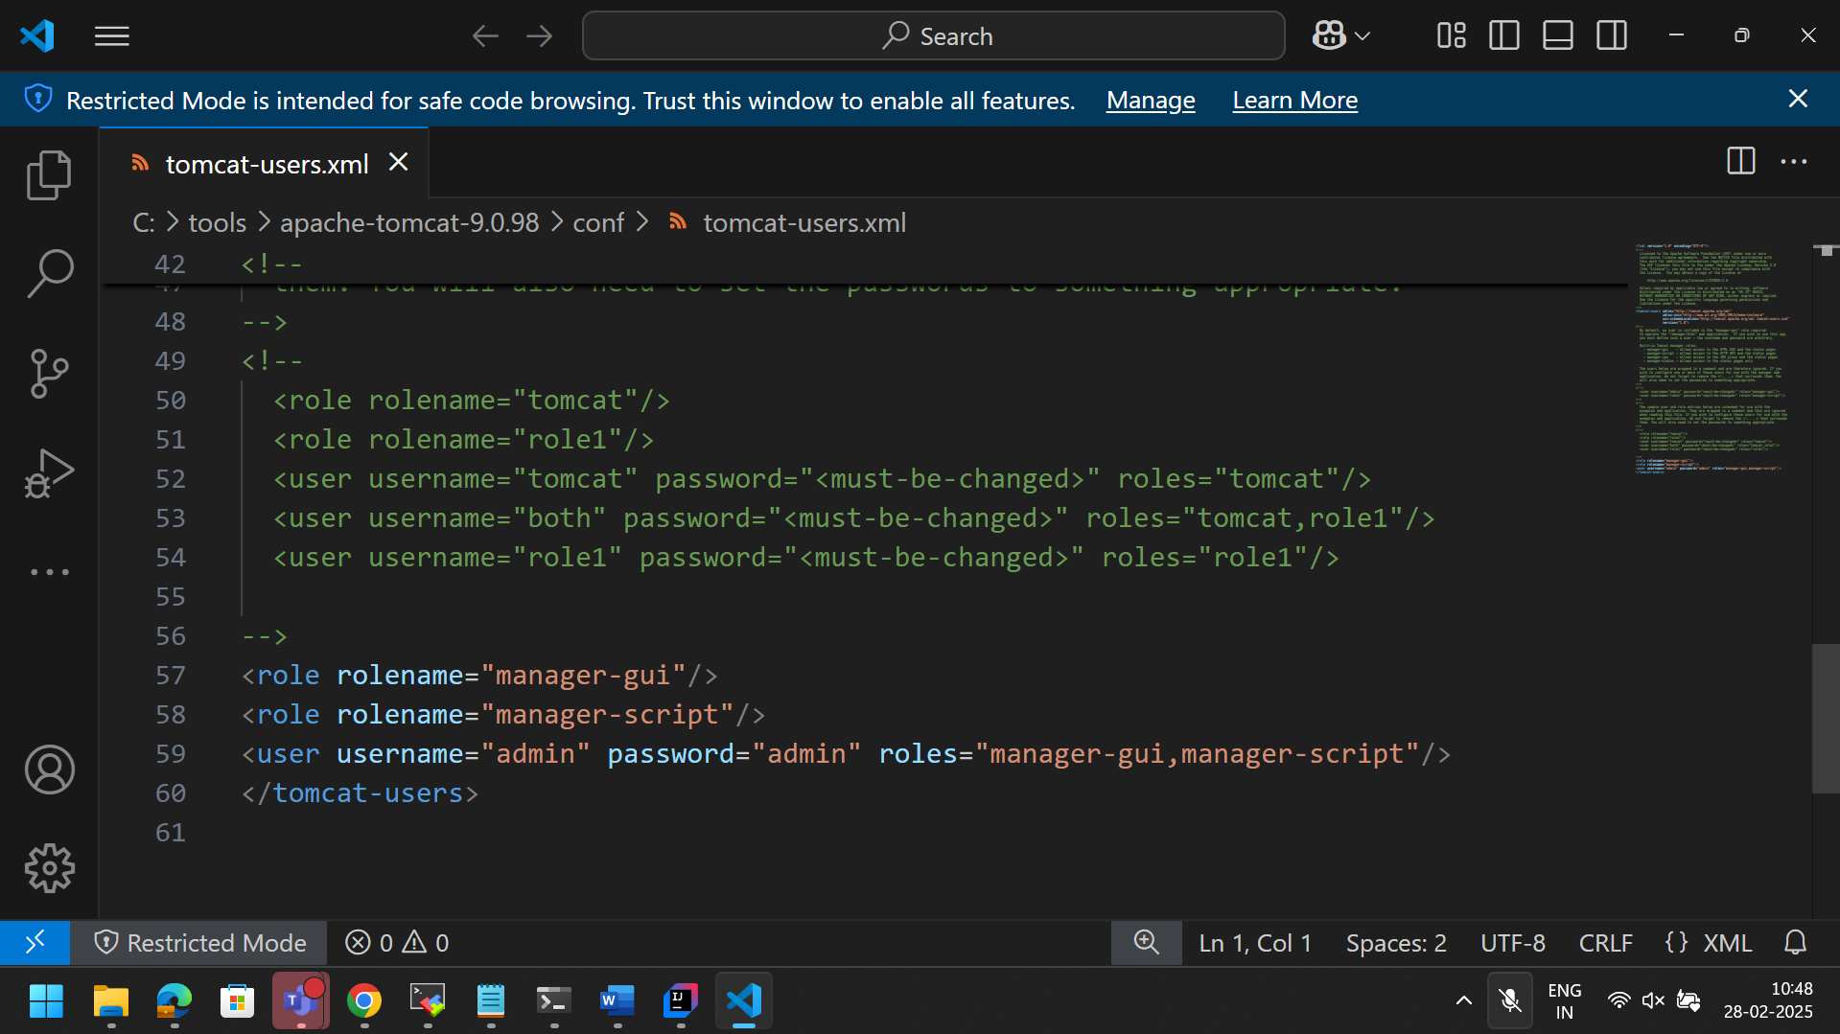

Tomcat server running and logged in
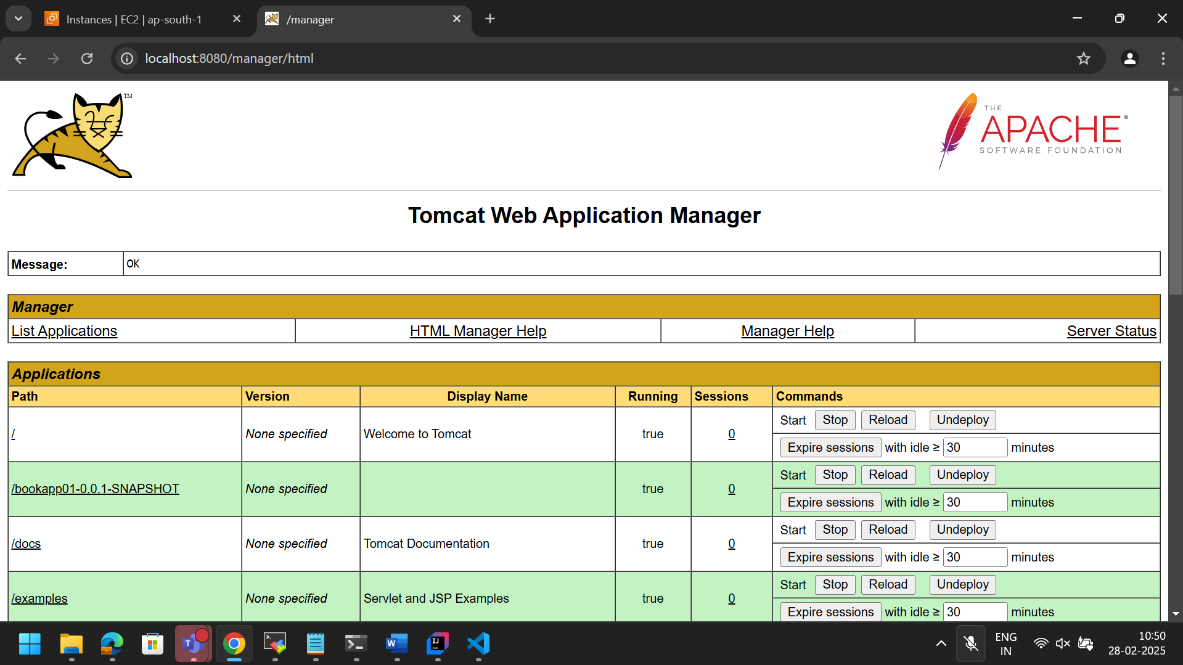

Deploy that war file
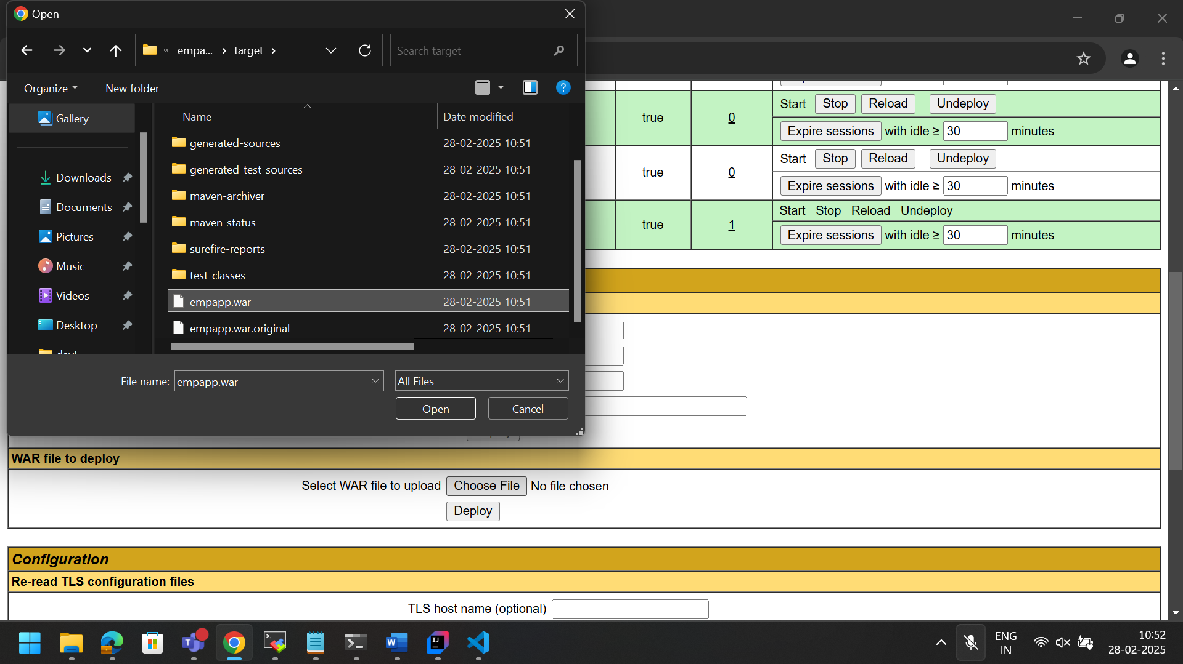

Running

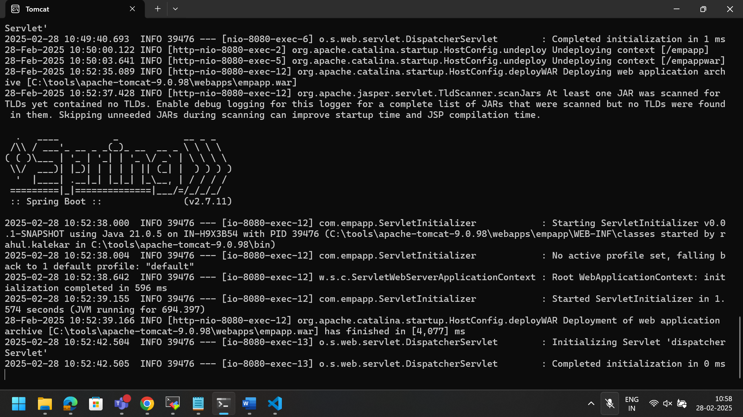
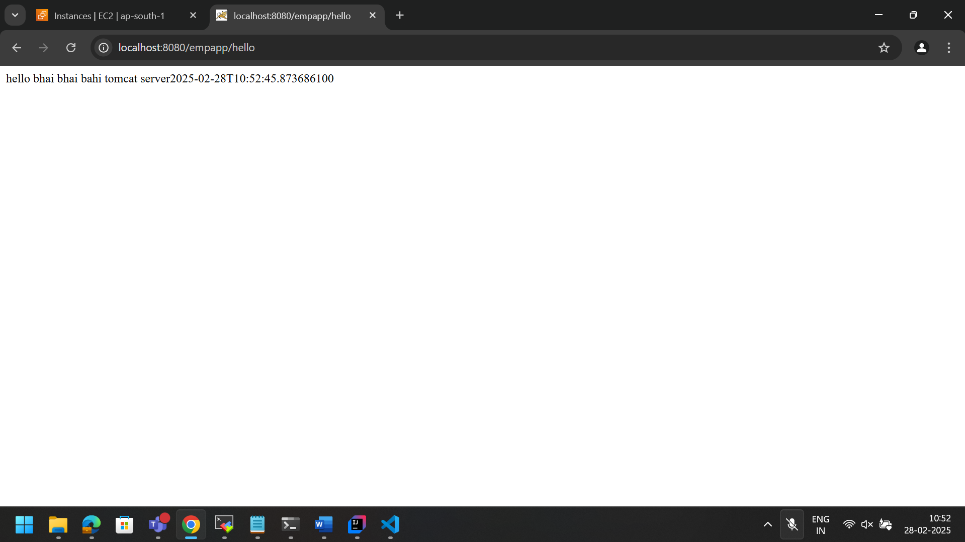

- Now automizing using Jenkins(Pipeline)

Start Jenkins

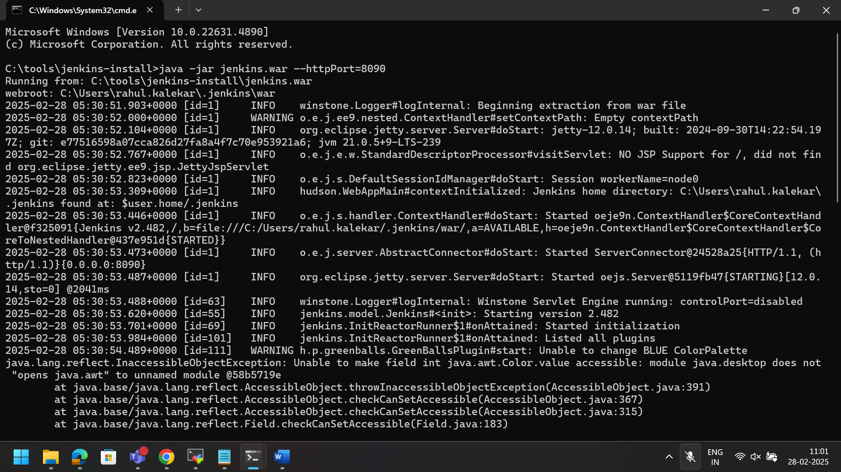

Configure Jenkins, install plugins green balls, maven integration , deploy to container

Configure maven home in tools
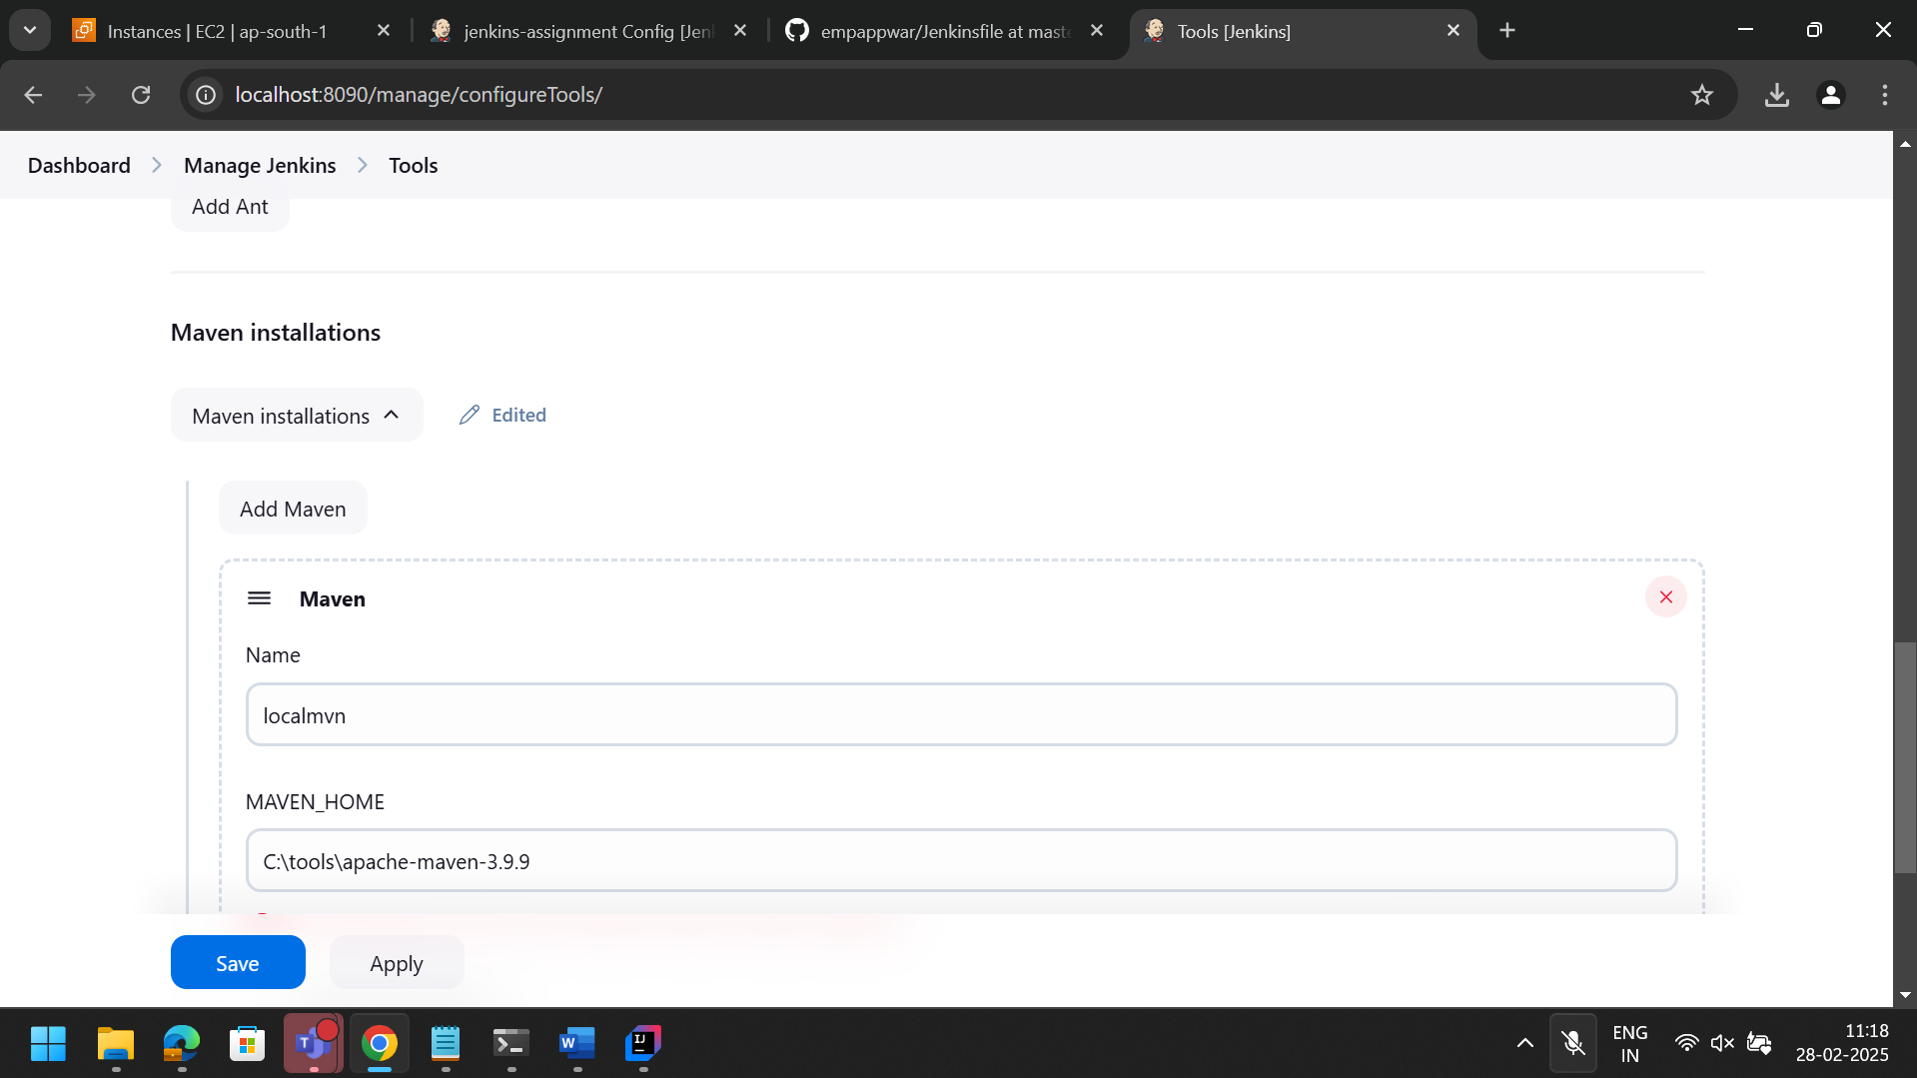

Upload the project on git

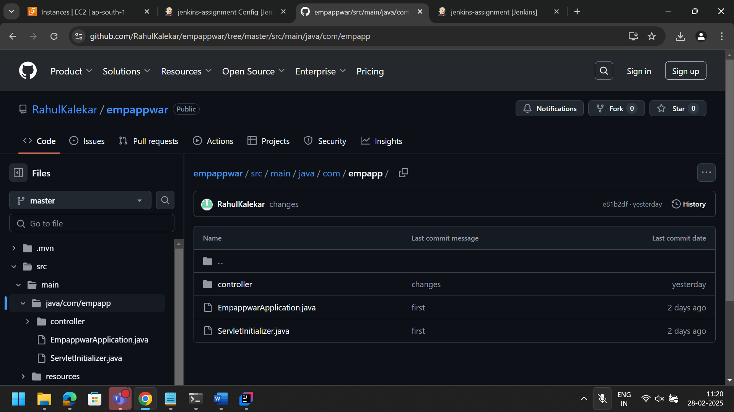

Added Jenkinsfile in root directory of project to use it for pipelining.

Jenkinsfile
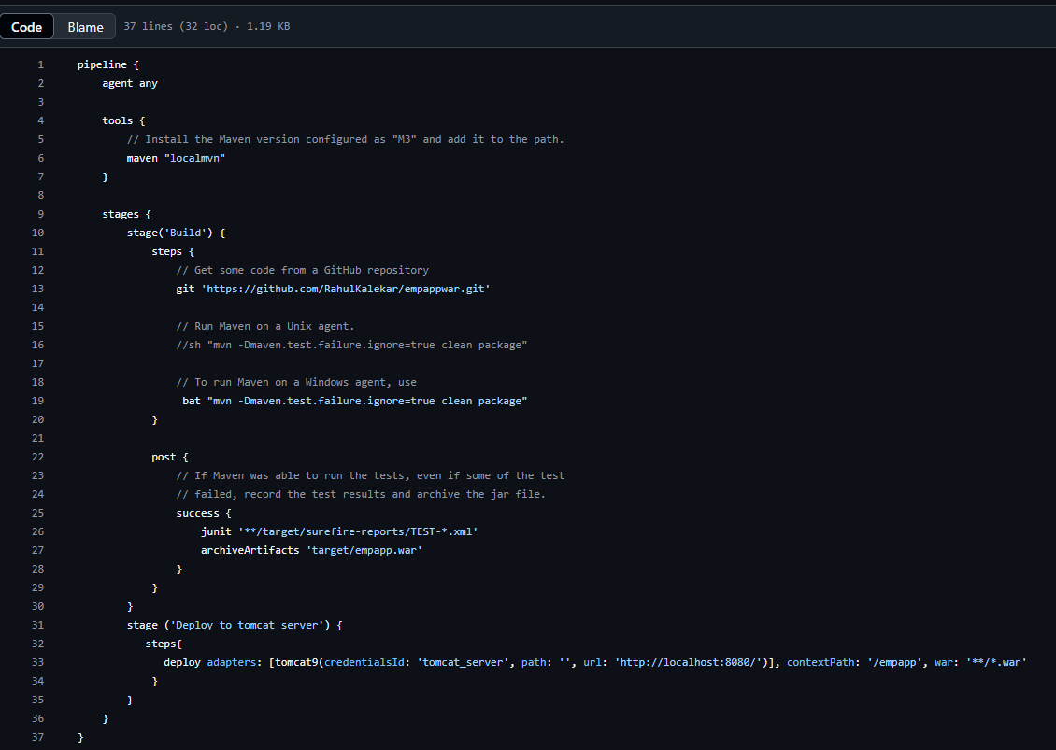

We need to add credentials for jenkins to access our tomcat server, so
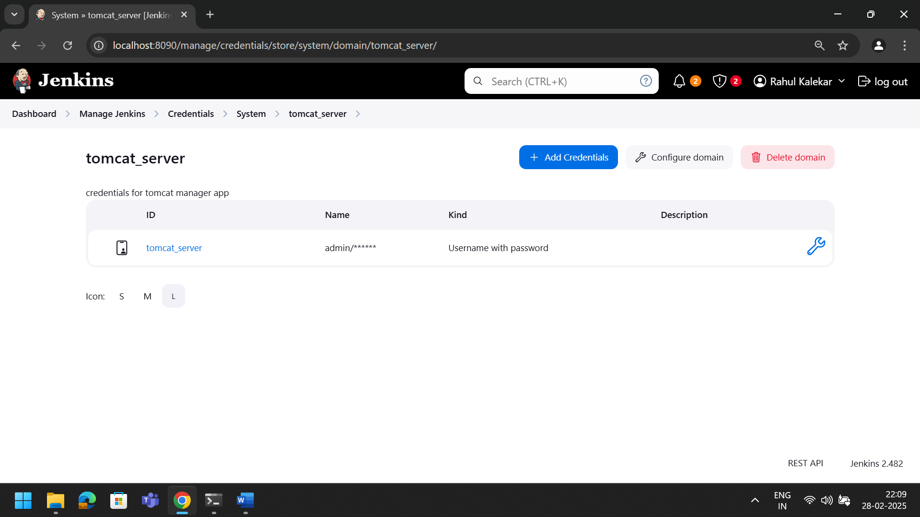

Created tomcat_server credentials which has tomcat server manager app id pass.

Creating pipeline project
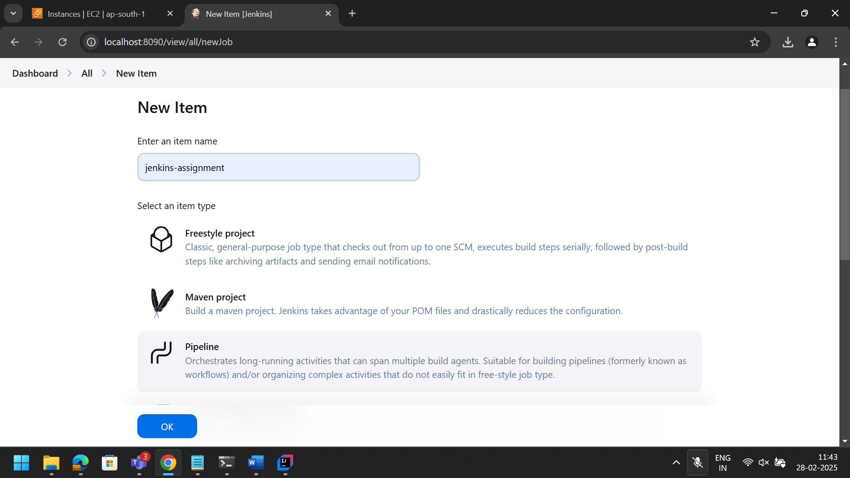

Pipline script from SCM
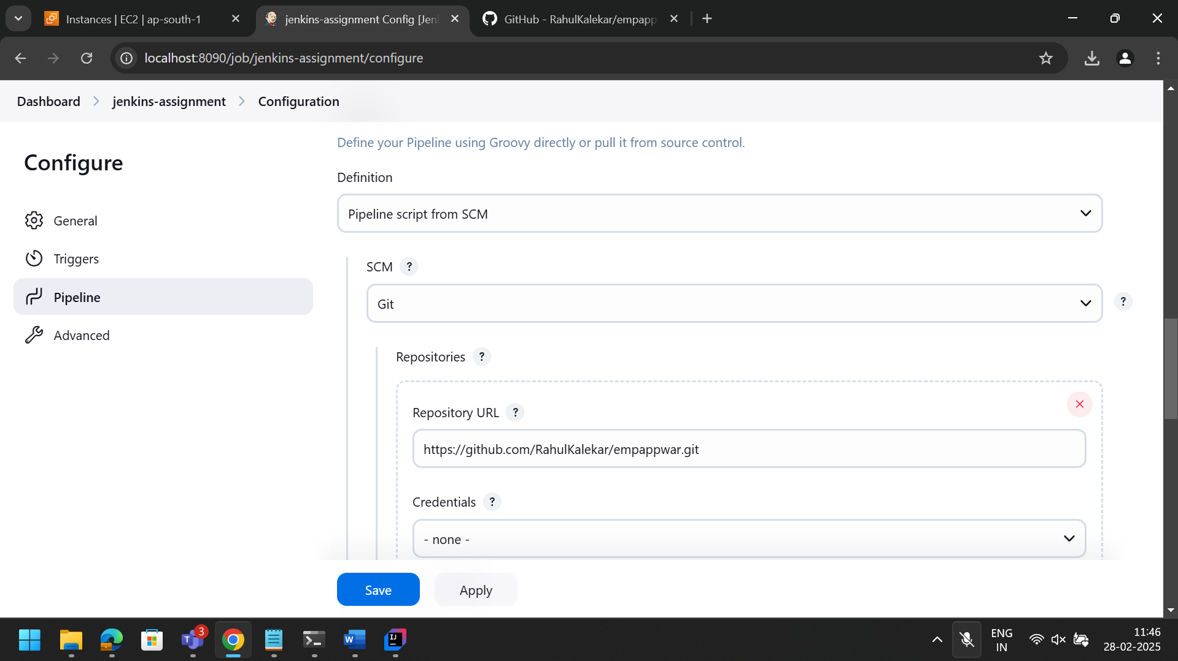

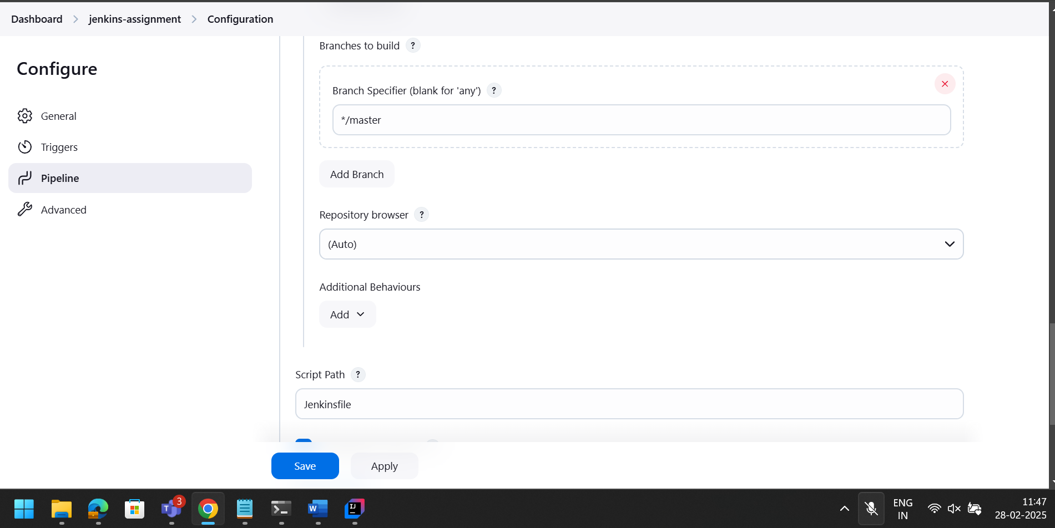

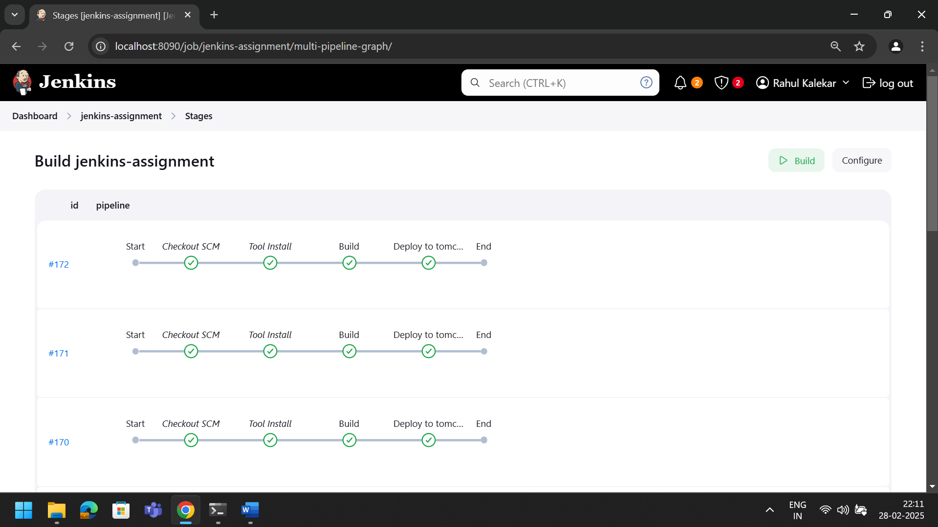

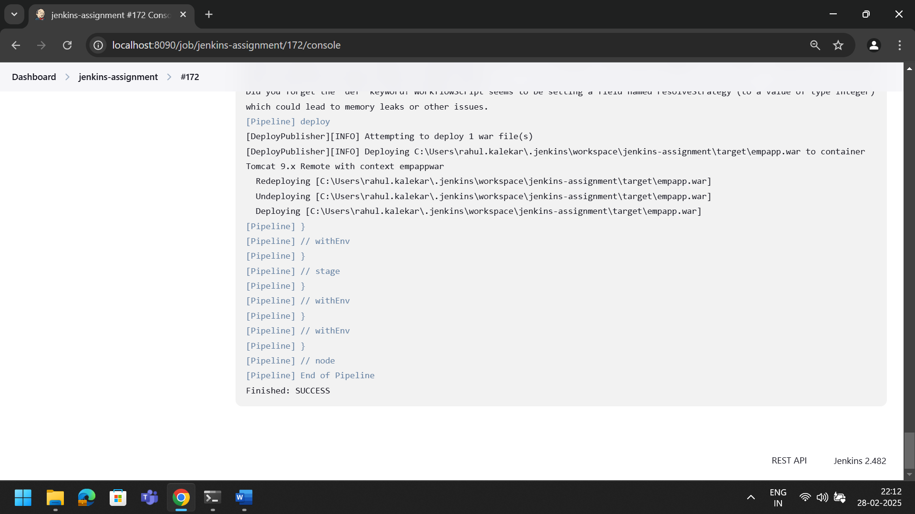

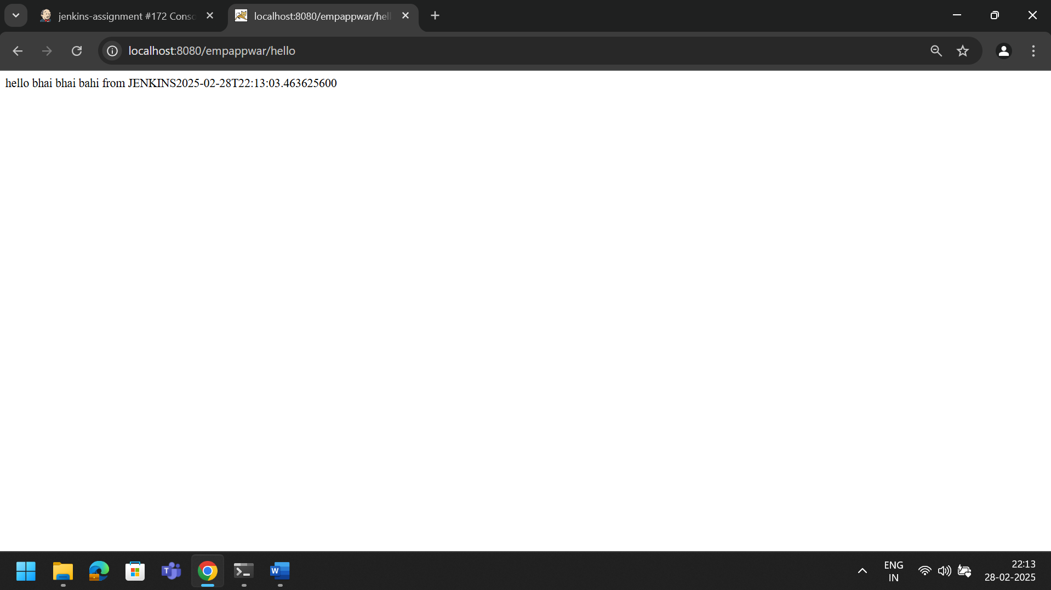

Assignment 2:
Create spring rest project and deploy it on docker hub using jenkin

